The Girl Gifted With the Light
The Girl Gifted With the Light
– Maura Fitzsimons, pbvm
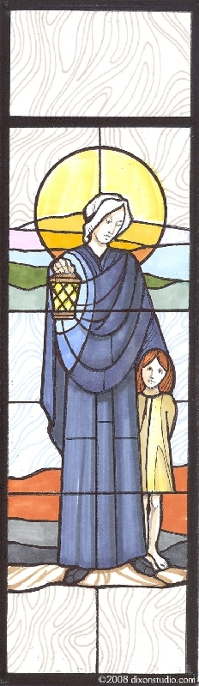
“What will become of her,”
The mother mused,
As Nano galloped back and forth across the fields –
Not heeding any mark of blame
Or that the insight of her dad
Should see in her a sainted name.
On mounted steed she sprinted on
As if she sat of gifted dreams.
Like any wistful lass,
She dared to risk the unforeseen.

A youth of Ireland’s darkest hour
When education was denied
And alliance split apart,
Nano – Gifted with the power of dreams
Grew in sanctions of the heart;
And the Nagle vision served her well.
When hidden hope and family means
Provided her escape to France,
Where she with leisure would dispel
Her inborn gifts,
And take to heart the social life
That would her young beliefs enhance.

Being of the upper class
She mingled with the high elite,
Until the morning dawn,
When painful tears awakened her
To service needs at home...
We see her now beyond her years
Her gifts released and blessed.
As onwards through the age of time
Her followers fill her soul’s request,
To be of service in a world of need
And advocate for justice rights –
Or through a giving hand, a smile, a prayer
Bring to the down and lowly one,
a ray of lived delight.

