'In Praise of Nano's Spirituality' by Sr Pius O'Farrell, PBVM
We are very happy to share this reflection which Sr Pius O’Farrell has written. Across the Presentation world we are well aware of the profound and professional contribution which Sr Pius has made in making Nano and her vision known. In the 1980’s and 1990’s Sr Pius worked tirelessly to write the Positio for the Congregation so that Nano’s cause can be furthered. She has written two wonderful books on Nano, Breaking of Morn and Nano Nagle, Woman of the Gospel. They are inspirational and informative. Many of us look to her writings to deepen our own understanding of Nano and her vision. She also produced CD’s, so that those who have special needs can dip into the spirit of this valiant woman. She has walked with many of us on the ‘Nano Walk’ in Cork.
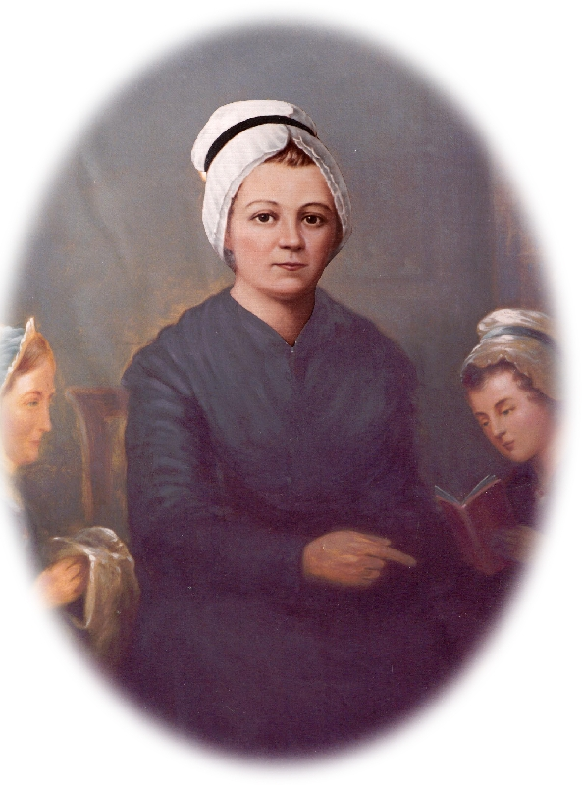
To quote her own words from Nano Nagle, Woman of the Gospel “to the people of Cork she gave not just a piece of silk but her whole life. Their needs were so great that she was drawn into ever greater service, into ever deeper poverty, into continual demands of her time. In school and street, she gave what she had. To her, everyone in need was Christ asking for help...It was all ‘of the Sacred Heart’. Love and compassion outran every plan she made and every effort at conservation of resources.”
Sr Pius’s contribution is invaluable and will stand the test of time, it is a treasure house that we draw on each day. It will inspire millions across the globe and move us all to live deeply the spirit of Nano in our world.
Thank you Sr Pius and may you be blessed, you have been a blessing to the Congregation.
This booklet was commissioned by the Congregational Leadership Team of the Presentation Sisters (Union) 2006-2012, Srs Terry Abraham, Joan O’Sullivan, Mary Deane, Mary Hanrahan and Emer Manning.
To view the booklet, please click here

