A Song for Two Hundred Years
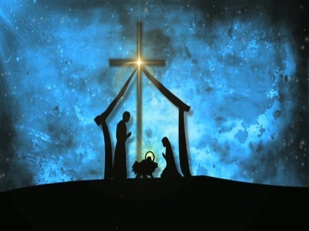
Song for Two Hundred Years
~ Sr Raphael Consedine, PBVM

Here is Bethleham.
From here went ringing far across the world
the singing news of God.
The poor who waited in the frozen dark
saw Life offered in the radiant Word,
and came with eager haste to find
Christ born to them.

Here is Bethlehem:
a woman pierced by the Spirit’s strength,
waiting in stillness on the Spirit’s strength,
empty of aught save the Spirit’s gift.
A woman faithful to the Word received,
whole in her heart and her hands to raise
a house built leaning on the breath of God.

