"I am Building a House": Nano Nagle's Georgian Convents by Dr Gillian O' Brien and Jessie Castle
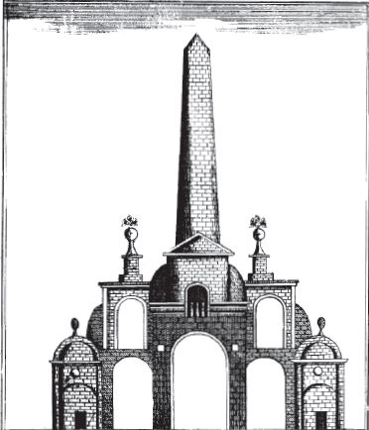
Gillian O’Brien and Jessie Castle found that relatively little had been written about the two convents that Nano Nagle (b. 1718) built for the Ursuline and Presentation Sisters. Given her very close (and enthusiastic) involvement in these projects they decided to write about the convents using information from Nano’s letters, the Annals and Account Books of both convents alongside the physical evidence from the convent she built in 1771 and other sources including newspapers and photographs. In telling the story of the two convents they are not just telling a story of bricks and mortar, but one of the determination and resilience of Nano Nagle as she strove to realise her dream of improving life for poor Catholic children in Cork and providing a safe home for both Ursuline and Presentation Sisters. In doing so she circumvented the Penal Laws, the demands of many local Protestants and, at times, even the demands of the Catholic hierarchy. Her achievement is really quite exceptional.
Gillian and Jessie would like to record their gratitude to the Irish Georgian Society for allowing the reproduction of the article which was published in the society’s journal Irish Architechtural and Decorative Studies. You can contact Gillian on email address: g.p.obrien@ljmu.ac.uk
To read the article, please click here

